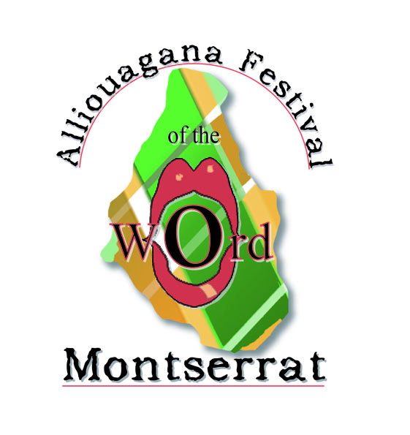

REGISTRATION FORM
The Alliouagana Festival of the Word does not require a registration fee. Please note that tickets will be sold for the Calypso Extravanganza and the Dramatic Presentations which are Festival Events. However, if participants wish to receive a Festival Bag containing a T-Shirt and various other giveaways from our partners, Money Orders in the amount of US$50 and made out to The Alliouagana Festival of the Word, should be mailed before October, 2009 to the following address:

Gracelyn Cassell
c/o The University of the West Indies
P. O. Box 350
Montserrat, West Indies

Completion of this registration form allows us to be able to meet and greet our Festival participants and to schedule persons for workshops and open mike sessions. Please send your completed form as soon as possible to gracelyn.cassell@open.uwi.edu or by fax to 664 491 8924.

Name: ___________________________ Mailing Address: ____________________________________________

Tel: ____________________ Fax: _____________________ E-mail: ____________________________________

TRAVEL INFORMATION (Montserrat leg of the Journey)

Arrival Date: _______________ Time: ________________ am/pm Flight:_______________________

Departure Date: _______________ Time: ________________ am/pm Flight:_______________________

ACCOMMODATION ARRANGEMENTS (Please give name of Hotel/Villa) _________________________________
If you are having any difficulty with your travel or accommodation arrangements, please let us know how we can help you.

FESTIVAL WORKSHOPS
As we try to finalise the provisional programme, kindly indicate which of the workshops you would like to attend. In the case of the writing workshops, you are expected to submit samples of your work in advance.

IN TRANSLATION with Edgar Nkosi White Yes □ No □

MEMOIR WRITING with Rachel Manley Yes □ No □

PUBLISHING WORKSHOP with Cherise Davis-Fisher (Editor in Chief, Plume) Yes □ No □

SHORT STORY WRITING with Professor Funso Aiyejina and Merle Hodge Yes □ No □

OPEN MIKE SESSIONS
I would like to participate in the Open Mike Session Yes □ No □

FESTIVAL BAG

I would like to receive a Festival Bag Yes □ No □

Please indicate T-Shirt Size: XX Large□ X Large□ Large□ Medium□ Small□ Other□

